Contents

[Introduction 2](#_Toc466382163)

[General overview of the process 2](#_Toc466382164)

[Terminology 2](#_Toc466382165)

[Time allocated and productivity metric 2](#_Toc466382166)

[Turnaround time 2](#_Toc466382167)

[CnE LM Role 3](#_Toc466382168)

[GitHub Pull Request Triage Step-by-Step Demo 4](#_Toc466382169)

[Step1: Engineering team manages the setup of the Repository for which they will receive notifications in GitHub 4](#_Toc466382170)

[Step 2: Engineering Team receives notification e-mail 5](#_Toc466382171)

[Step 3. Engineering Team adds a label to identify the status of the request 6](#_Toc466382172)

[Step 4. Engineering Team performs the Contribution License Agreement (CLA) verification 6](#_Toc466382173)

[Step 5: Engineering Team forwards the Request to the LM 7](#_Toc466382174)

[Step 6: LM Triages the request 8](#_Toc466382175)

[Requests to accept 8](#_Toc466382176)

[Requests to reject 8](#_Toc466382177)

[Translation Approval Guide 9](#_Toc466382178)

[Requests to escalate 9](#_Toc466382179)

[Interaction with the contributor 10](#_Toc466382180)

[Step 6.1 Engineering Team accepts the request 10](#_Toc466382181)

[Step 6.2: Engineering Team rejects the request 11](#_Toc466382182)

[Step 7. LM implements changes in files 13](#_Toc466382183)

[GitHub: Getting Started Guide 14](#_Toc466382184)

[Recording of the live training delivered by MS 14](#_Toc466382185)

[Get familiar with Git Terms 14](#_Toc466382186)

[Create a GitHub account and set up your profile 14](#_Toc466382187)

[Install Git for Windows 14](#_Toc466382188)

[Enable two-factor authentication 15](#_Toc466382189)

[What is GITHUB Pull Request (PR)? 16](#_Toc466382190)

[What are you looking for in a Pull Request? 16](#_Toc466382191)

[Accessing Azure/acom string repository 17](#_Toc466382192)

[Associate your GitHub identity with your Microsoft identity 17](#_Toc466382193)

[Join the Azure organization on GitHub 19](#_Toc466382194)

[Configure Multi Factor Authentication to protect your GitHub account 20](#_Toc466382195)

[Request access to the acom-read team 21](#_Toc466382196)

[How to ask permission to the Azure groups: 24](#_Toc466382197)

# Introduction

## General overview of the process

1. End users enter linguistic suggestions / change requests in GitHub in the form of Pull Request (PR).
2. LMs receive an email from engineering team with the request submitted by the end user.
3. Within 48 hours from the engineering Team’s request, LMs confirm if the request from the end user should be applied or rejected, always referring to:

* MS TermStudio
* MS Style Guide
* [CnE Knowledge Portal](https://portal.moravia.com/prj/msce/LinguisticServices/wiki/_layouts/15/start.aspx#/SitePages/CnE%20Knowledge%20Portal.aspx)

1. Within 72 hours from the engineering Team’s request, LMs reply to the engineering team providing:

* A clear and detailed linguistic justification for the rejection / acceptance
* The response template that should be used to reply the end user using templates in [Communication with the Contributor](onenote:#Communication%20with%20the%20Contributor&section-id={1CB4385D-00D7-4787-94E0-6DF1547065DD}&page-id={AD36521A-023B-47A0-852D-25A2A50E8863}&end&base-path=https://microsoft.sharepoint.com/teams/CEIntl/LocKit/OneNote%20Library/Content%20Notebook/GitHub-DPS.Cu)

1. Engineering team enters LMs feedback in GitHub + template.
2. Engineering team assigns the modified file to the LM via OddJob.
3. LM implements approved changes in the file in OddJob.

### Terminology

If the request generates new terms or term changes, LMs sends an email immediately to Valerie Dokic Nemeckova [vnemeckova@moravia.com](mailto:vnemeckova@moravia.com)

## Time allocated and productivity metric

**The time allocated for this task is 5 hours per week: if you receive more work, please escalate IMMEDIATELY to the PM**.

**The proposed Productivity rates are as follows:**

* Rejecting requests: 8 request per one hour
* Accepting a request and implementing the fix: 4 requests per one hour

Whenever the LM needs more time, the LM must escalate this immediately to the PM to agree on a new productivity rate.

## Turnaround time

The general TAT are as follows:

***Accept*** *= Responding to engineering team + providing response template + editing the file in OddJob*

***Reject*** *= Responding to engineering team + providing response template*

1. Engineering Team receives a GitHub Pull Request and forwards it to the LM
   * The engineering team will monitor the repositories daily to see if any feedback has been published.
2. LM performs triage
   * LM has 48 hours to communicate the next step to the engeneering team ==> Accept, Reject or need to Escalate
3. Escalation
   * Email sent to the escalated target people within 72 hours after step A
     + Escalate to engineering team: e-mail sent out
     + Escalate to Term team: term change request ticket filed
     + Escalate to EN-US team: submitted the PR in azure-content-pr
   * Communicate with the contributor within 72 hours, see the response template in Case #4 @[Communication with the contributor](onenote:#Communication%20with%20the%20contributor%20&section-id={1CB4385D-00D7-4787-94E0-6DF1547065DD}&page-id={AD36521A-023B-47A0-852D-25A2A50E8863}&end&base-path=https://microsoft.sharepoint.com/teams/CEIntl/LocKit/OneNote%20Library/Content%20Notebook/GitHub-DPS)
   * Always sync up with the contributor in every 3 days if you don't receive the escalation response, see the response template in Case #5 @[Communication with the contributor](onenote:#Communication%20with%20the%20contributor%20&section-id={1CB4385D-00D7-4787-94E0-6DF1547065DD}&page-id={AD36521A-023B-47A0-852D-25A2A50E8863}&end&base-path=https://microsoft.sharepoint.com/teams/CEIntl/LocKit/OneNote%20Library/Content%20Notebook/GitHub-DPS), and send reminder to the escalated target people (writer, IPM, or MOR term team)

1. LM responds to the engineering team
   * ***Accept*** without escalation: within 72 hours after step A
   * ***Accept*** with escalation:
     + Within 24 hours after receive the escalation feedback.
   * ***Reject*** without escalation: within 72 hours after step A
   * ***Reject*** with escalation:
     + Within 24 hours after receive the escalation feedback.

## CnE LM Role

|  |  |
| --- | --- |
| **Role in GitHub** | **Tasks** |
| Reply to the request from the engineering team | 1. Confirm if the feedback should or should not be implemented 2. Determine whether the translation applies to all languages, aka whether the EN-US source should be updated 3. Provide the engineering team with the EN feedback into the localized reply. If the feedback should be escalated to the English writer, then ask the engineering team to submit the GitHub Pull Request (PR) to communicate with the English writer. |

# GitHub Pull Request Triage Step-by-Step Demo

## Step1: Engineering team manages the setup of the Repository for which they will receive notifications in GitHub

Refer to: <https://help.github.com/articles/watching-repositories/>:

1. Engineering Team Ensures that the primary GitHub email address is set to the MS v- alias:
   1. Go to <https://github.com/settings/emails>
   2. Ensure the Microsoft v- alias shows as Primary:

Machine generated alternative text:
Personal settings 
Profile 
Account settings 
Emails 
Notification center 
Billing 
SSH keys 
Security 
Applications 
Email 
Your primary GitHub email address will be used for account-related notifications (e.g_ account changes and billing 
receipts) as well as any web-based GitHub operations (eg_ edits and 
microsoft.com 
Add email address 
Add 
Keep my email address private 
We win use SunnyDeng@users.norepIy.github.com when performing web-based Git operations and sending email on your 
behalf. If you want command line Git operations to use your private eman you must set your email in Git 

Go to the repository you want to watch, for example: <https://github.com/Azure/azure-content-dede>

1. Select 'Watch'/'Unwatch' button to enable/disable the notification

Machine generated alternative text:
Azure / azure-content-dede 
Unwatch • 
46 
Star o 
Fork 3 

Machine generated alternative text:
Azure / azure-content-dede 
Wild 
pulse 
Unwatch • 
Notifications 
46 
Star 
Fork 
O Code 
O 
Issues o 
Pull requests 2 
Graphs 
Not watching 
Be notified when particiating or@mentioned. 
Watching 
Be notified of all conversations. 
Ignoring 
Never be notified. 
this is the public repo for de-de external customer to contribute the Acom Doc Center transla 
G) 769 commits 
New pull request 
1 branch 
New file 
Find file 
e:) 20 releases 
Branch: 
HTTPS 
https:// 

1. After setting up the notification, go to GITHUB account 'Settings' -> 'Notification Center', check 'Email' and 'Web'. It will allow you to receive e-mails and know if a new request comes to the repository you are following.

Machine generated alternative text:
Signed in as SunnyDeng 
Your profile 
Your stars 
Explore 
Integrations 
Help 
Settings 
Sign out 

Machine generated alternative text:
Search GitHub 
Personal settings 
Profile 
Account settings 
Emails 
Notification center 
Billing 
SSH keys 
Security 
Applications 
Personal access tokens 
Repositories 
Pull requests 
How you receive notifications 
Automatic watching 
Issues 
Gist 
When you're given push access to a repository, automatically receive notifications for it. 
Automatically watch repositories 
Participating 
When you participate in a conversation or someone brings you in with an @mention. 
u Email 
Watching 
updates to any repositories or threads you're watching_ 
el Email el Web 
@ Your notification settings apply to the repositories you're watching. 

## Step 2: Engineering Team receives notification e-mail

When an external customer submits a request, Engineering Team will receive an e-mail with:

1. **FROM** = the customer e-mail alias (which s/he registered and associated with his/her GitHub account)
2. **TITLE** = the PR name she/he inputs in GitHub. For example:

Machine generated alternative text:
Tue 1/5/2016 2:38 PM 
Carsten Kneip «otifications@github.con» 
(azure-content-dedel Took out extra space in "z.B." in line 23 (#3) 
To CJ Azure 'azure-content-dede 
O Click here to download pictures. To help protect your privacy, Outlook prevented automatic download of some pictures in this message. 
Delve Analytics 
Report Suspicious Email 
Org Tree 
Who's Who 
You can view, comment on, or merge this pull request online at: 
https://github.com/Azure/azure-content-dede/pu11/3 
Commit Summary 
Took out extra dot in "z_B_" in line 23 
File Changes 
Patch Links: 
https://github.com/Azure/azure-content-dede/pu11/3 _ patch 
https://github.com/Azure/azure-content-dede/pu11/3 _ di ff 
Reply to this email directly or view it on GitHub_ 

## Step 3. Engineering Team adds a label to identify the status of the request

Please refer to [How to add label to PR](onenote:#How%20to%20add%20label%20to%20PR&section-id={1CB4385D-00D7-4787-94E0-6DF1547065DD}&page-id={658B01A3-BFED-4995-8ED8-FE9C2CDC7190}&end&base-path=https://microsoft.sharepoint.com/teams/CEIntl/LocKit/OneNote%20Library/Content%20Notebook/GitHub-DPS.Current.on)

## Step 4. Engineering Team performs the Contribution License Agreement (CLA) verification

1. If the second e-mail doesn't require the customer to signoff CLA, go to Step 5.

Machine generated alternative text:
added the word 'als' in line 30. 
Merged 
SunnyDeng merged 1 commit into Azure:master trom karinanderke:patch-l on Jan 8 
991B55f 
Microsoft member X 
Labels 
cla-not-required 
No milestone 
Assignee 
No one—assign yourself 
Notifications 
Unsubscribe 
You're receiving notifications 
because you modified the open/close 
3 participants 
Edit 
Conversation 3 
o Commits 1 
Files changed 1 
3e. 
karinanderke commented on Jan 6 
No descnpt/on provided 
added the 'als' 
azurecla commented on Jan 6 
line 
Hi @karinanderke, I'm your friendly neighborhood Azure Pull Request Bot (You can call me 
Thanks tor your contribution' 
This seems like a small (but important) contribution, so no contribution license agreement is required at this 
point. Real humans will now evaluate your PR. 
TTYL, AZPRBOT; 
azurecla added the 
• label on Jan 6 
cla-not-required 

1. If the second e-mail requires the customer to signoff CLA, then wait for the CLA to be signed
   1. You will also notice 'cla-required' as **red** label in the request
   2. After the end user signed the CLA, you will see 'cla-signed' as **green** label in PR added automatically.

Machine generated alternative text:
azurecla commented 28 days ago 
Collaborator 
Hi @ccasbre27, I'm your friendly neighborhood Azure Pull Request Bot (You can call me AZPRBOT)_ 
Thanks for your contribution' 
In order for us to evaluate and accept your PR, we ask that you sign a contribution license agreement. It's 
all electronic and will take just minutes. I promise there's no faxing. https://cla.azure_com_ 
TTYL, AZPRBOT 
O azurecla added the 
cla-required 
label 28 days ago 
Collaborator 
rmca14 added the 
azurecla commented 21 days ago 
label 28 days ago 
@ccasbre27, Thanks for signing the contribution license agreement so quickly' Actual humans will now 
validate the agreement and then evaluate the PR. 
labels 21 days ago 
Thanks, AZPRBOT, 
O azurecla added 
and removed 

Important ***If 'cla-required' label is added, PR reviewer can't respond the PR before 'cla-signed' label is added.***

## Step 5: Engineering Team forwards the Request to the LM

1. Open the first e-mail, for example:

Machine generated alternative text:
You can view, comment on, or merge this pull request online at: 
https://github.com/Azure/azure-content-dede/pulV4 
Commit Summary 
added the word 'als' in line 30. 
File Changes 
M articles/event-hubs/event-hubs-availability-and-support-fiq _md (4) 
Patch Links: 
https://github.com/Azure/azure-content-dede/pu11/4_patch 
https://github.com/Azure/azure-content-dede/pu11/4_diff 
Reply to this email directly or view it on GitHub_ 

1. Click the first link with the Pull Request number to go to the PR UI page in GITHUB, for example:

Machine generated alternative text:
Azure I azure-content-dede 
@ Unvatch • 
991essf 
46 
star 
Fork 
Issues o 
n Pull requests 2 
added the word 'als' in 
line 30. 
n Open 
karinanderke wants to merge 1 commit into from karlnandeeke:pat h 1 
Conversation 1 
o Com'Wts 1 
(3 Files changed 1 
Be. 
karinanderke comtnented 2 days ago 
No description provided 
added the word 'als• in 
azurecla commented 2 days ago 
line 
red 
Assignee 
No one—assign yourself 
Unsubscrn»e 
You're notifications 
because you're subscribed to this 
repostory _ 
2 participants 
Lock conversation 
Hi earinanderke, I'm your friendly neighborhood Azure Pull Request Bot (You can call me AZPRBOT). 
Thanks for your contribution' 
This seems like a small (but important) contribution, so no contribution license agreement is required at this 
point Real humans will now evaluate your PR 
TTYL, AZPRBOT; 
O azurecla added the 
label 2 days ago 
cla-not-required 
This branch has no conflicts with the base branch 
Merging can be performed automatically. 
Merge pull request 
You can also open this in GitHub Desktop or view command line instructions. 

1. Click the link under 'File Changes': it will bring you to the file change UI page in GitHub, Click the 'File changed' tab where the changes are listed.

*For example:*

Machine generated alternative text:
Azure I azure-content-dede 
Graphs 
@ Unvatch • 
46 
star 
Fork 
split 
Issues o 
n Pull requests 2 
added the word 'als' in line 30. 
n Open 
karinanderke wants to merge 1 commit into from karlnandeeke:pat h 1 
Conversation 1 
o Com'Wts 1 
Files changed 1 
Showing 1 changed file with 2 additions and 2 deletions. 
articles/event-hubs/event-hubs-availability-and-support-faq.md 
-27,7 +27,7 @@ Lim-Fassende Informaticnen den Preisen von Event Hubs f inden Sie unter H 
## "ie werden Eingangsereignisse von Event Hubs berechnet? 
Unified 
View 
Wie werden Eingangsereignisse von Event Ribs berechnet? 
-Jedes an einen Event Hub gesendete Ereignis wird als abrechenbare Nachricht gezÉhIt. 
+Jedes an einen Event Hub gesendete Ereignis wird als abrechenbare Nachricht gezÉhIt. 
Ein ist als eine Dateneinheit definiert, die kleiner als oder 
gleich S4 KB 1st. Jedes Ereignis, das kleiner als oder gleich 64 KB ist, gilt als 
kostenpflichtig. Wenn das Ereignis grtßer als 64 KB ist, wind die Anzahl der 
abzurechnenden Ereignisse genäß der Ereignisgröße in Vielfachen von 64 KB 
berechnet. Beispielsweise wird ein an ein Event Hub gesendetes 8-KB-Ereignis als 
ein Ereignis abgerechnet, aber eine Nachricht in der Größe von 96 KB, die an ein 
Event Hub gesendet wird, wird als Ereignisse in Rechnung gestellt. 
Von eimen Event Hub genutzte Ereignisse so•a'ie Verwaltungsvorgänge und 
Kontrollaufrufe Kie etwa Checkpoints werden nicht als abzurechmende 
Eingangsereignisse gezählt, sondern bis zur erlaubten Durchsatzeinheit angesawelt. 
(Beispielanwendung mit Ver•endung von Ereignis-Hubsl: 
https://code.msdn . microsoft. cw/Service-Bus- Event-Hub-28Sfde97 
(Nessaginglösung mit "arteschlangel: . ./service-bus/serwice-bus-dotnet-multi-tier- 
app -using- service-bus-queues. md 
+4! _--Hmumber:AcomDC 12B 2e1s--» 
Ein ist als eine Dateneinheit definiert, die kleiner oder 
64 KB 1st. ledes Ereignis, das kleiner als oder gleich S4 KB 1st, gilt als 
kostenpflichtig. Kenn das Ereignis größer als €4 KB ist, wird die Anzahl der 
abzurechnemden Ereignisse genäß der Ereignisgröße in Vielfachen von S4 KB 
berechnet. Beispielsweise ein an ein Event Rib gesendetes 8-KB-Ereignis 
ein Ereignis abgerechnet, aber eine Nachricht in der Größe von 96 KB, die an 
Event Hub gesendet wird, wird als zwei Ereignisse in Rechnung gestellt. 
Von einem Event Hub genutzte Ereignisse sowie VerwaItungsvorgÉnge und 
Kontrollaufrufe wie etwa Checkpoints werden nicht als abzurechnende 
gleich 
den 
Eingangsereignisse gezählt, sondern bis zur erlaubten Durchsatzeinheit angesaæelt. 
-Ile,4 +213,4 Wei tere Inform-ticnen zu Event Hubs f inden Sie in den folgenden Artikeln: 
(Beispielanwendung mit Verwendung von Ereignis-HubsJ: 
https://code.msdn . microsoft. cw/Service-Bus- Event-Hub-28Sfdø97 
(Messaginglösung mit NarteschIangeJ: . ./service-bus/service-bus-dotnet-multi-tier- 
app-using- service-bus-queues. md 
-4! ---'-mu•erzAcowc 120 2815-0 
113 

Please refer to [Types of PR VIEW](onenote:#Types%20of%20PR%20VIEW&section-id={1CB4385D-00D7-4787-94E0-6DF1547065DD}&page-id={C972E054-8679-4233-87CC-743A34116124}&end&base-path=https://microsoft.sharepoint.com/teams/CEIntl/LocKit/OneNote%20Library/Content%20Notebook/GitHub-DPS.Current.one), to select the view that you like.

Please refer to [How to check the relevant source (EN) strings](onenote:#How%20to%20check%20the%20relevant%20source%20(EN)%20strings&section-id={1CB4385D-00D7-4787-94E0-6DF1547065DD}&page-id={83851ABE-190E-4973-9BB7-E96D081E04DA}&end&base-path=https://microsoft.sharepoint.com/teams/CEIntl/LocKit/OneNote%20Library/Content%20Not), to find how to check the en-us strings.

## Step 6: LM Triages the request

### Requests to accept

1. Mistranslation correction
2. Style correction
3. Terminology change request (LM should follow escalation to the terminology team)
4. New Terminology (LM should follow escalation to the terminology team)
5. Correction of source string

\*\*\*For different scenarios, escalate to MS IPM through e-mail: Jason Card (Moravia IT AS (USD)) <v-jacard@microsoft.com>

### Requests to reject

1. Requests to translate a new article/paragraph
2. Requests to add new images or change images
3. Transcreation requests
4. Country specific change about feature and its specific environment
5. If the UI string is unlocalized in content, don't accept the translated UI strings as the feedback.
6. Not accept the PR with merge conflict, ask contributor to resolve the conflict or resubmit the PR.
7. Requests to change metadata. For example:

Machine generated alternative text:
O Edit file 
properties 
1 
Preview changes 
ao Servico do contäiner do Azure I Microsoft Azure" 
Spaces 
Soft wrap 
configuragäo e gerenciamento de um 
description: "O ACS (Servico de container do Azure) fornece uma maneira de simplificar a criacäo, 
cluster de maquinas virtuais que Sio pré-configuradas para executar aplicativos contidos. " 
services:" virtual-machines" 
documentationcenterz " " 
authors: " rgardler" 
manager: "nepeters " 
editor:"" 
tags: "acs, azure-container -service" 
contäineres, Microsservicos, 
(tags 
ms . -machines" 
ms . 
ms . topic:" hone-page" 
ms . 
ms . workload: " na" 
ms . date: "12/82/2e1s" 
ms . author:" rogardle"/» 
# Introdugäo ao Servico de contéiner do Azure 
Nesos, 
Azure"/ * 
O ACS (Servico de contäiner do Azure) fornece uma maneira de simplificar a criagäo, configuracäo e gerenciamento de um cluster de 
maquinas virtuais que säo pré-configuradas para executar aplicativos contidos. Usando uma configuracäo otimizada de ferramentas 
populares de agendanento e orquestracäo de cédigo-fonte aberto, o ACS permite que VOCE use suas habilidades existentes ou explore uma 
experiäncia cada vez maior da comunidade para implantar e gerenciar aplicativos baseados em contäiner no Microsoft Azure. 

1. Do not accept any change requests on the final line, e.g. <!---HONumber=AcomDC\_<date>\_<year>-->. This is a very important and internal comment that the engineering team implements on files. As a result, discard any request that suggest changes of any kind on this comments.

Machine generated alternative text:
azure-content-ptbr-pr I articles / acs / 
O Edit file Preview changes 
CLI o Docker e Docker Compose 
Krane 
Jenkins 
acs-intro_md 
or cancel 
Spaces 
Soft wrap 
199 
A documentacäo completa e o suporte seräo fornecidos aos participantes da visualizagäo e serio publicados aqui depois que o servico 
estiver aberto para o püblico. 
Obtendo aces so 
Enquanto o servigo esté no modo de visualizacäo, pedimos que aqueles que estäo interessados em testar o servigo tse 
autodesigneml(http://aka.ms/acspreview). Primeiro, seré necessério uma Assinatura do Azure; se vocä näo tiver uma, porque näo se 
inscrever para obter uma Cavaliacäo gratuita)(http://azure.microsoft.com/pricing/free-triaI/?"T.mc id—A44CIC93S)? 
videos 
Comunicado sobre o AzureCon: 
CAZURE . VIDEO azurecon-2e1S-deep-dive-on-the-azure-container-serwice-with-mesos) 
Introducäo ao ACS: 
CAZURE . VIDEO connect-2e1S-getting-started-deveIoping-with-docker-and-azure-container-service) 
0---HONumber:AcomDC 12B 2e1s--» 

\*\*\*For different scenarios, escalate to MS IPM through e-mail: Jason Card (Moravia IT AS (USD)) <v-jacard@microsoft.com>

### Translation Approval Guide

* When you approve a change:
  + Merge if the translation suggestion doesn't pollute TM. This means that if you have a source segment that has 2 translations, this could generate inconsistencies and pollute the TM. If a source segment is split into 2 segments, this could damage the TM as well.
  + If there is a potential TM pollution risk, then try to rewrite the suggestion and confirm with the contributor/engineering team in PR comment thread, then ACCEPT.
* In one article or PR, if only partial of multiple changes comply with the Acceptance criteria, then this contribution is still considered as valid. ACCEPT, but before merge, the LM must:
  + Revert the rejected part back to the original translation in GITHUB raw file
  + List the general rejection reason, provide the positive feedback in PR comment.
  + Merge the PR (for the approved part)

### Requests to escalate

* Anything with uncertainty, please send e-mail to the Moravia requestor, who will send e-mail to MS project owner.
* Terms change request should be logged to the Portal <https://portal.moravia.com/prj/msce/terminology/_layouts/15/start.aspx#/Lists/Term%20Changes/AllItems.aspx>
* Term mining request should be addressed to the Terminology PM Valerie Dokic Nemeckova [vnemeckova@moravia.com](mailto:vnemeckova@moravia.com)
* English source string changes should be escalated to the EN-US writer following riles in [Working with EN authoring team on the EN Source issue](onenote:https://microsoft.sharepoint.com/teams/CEIntl/LocKit/OneNote%20Library/Content%20Notebook/GitHub-DPS.Current.one#Working%20with%20EN%20authoring%20team%20on%20the%20EN%20Source%20issue&section-id={1CB4385D-00D7-4787-94E0-6DF1547065DD}&page-id={33111FD9-F654-405B-A483-EBF41C0C392D}&end)  ([Web view](https://microsoft.sharepoint.com/teams/CEIntl/LocKit/_layouts/OneNote.aspx?id=%2Fteams%2FCEIntl%2FLocKit%2FOneNote%20Library%2FContent%20Notebook&wd=target%28GitHub-DPS.Current.one%7C1CB4385D-00D7-4787-94E0-6DF1547065DD%2FWorking%20with%20EN%20authoring%20team%20on%20the%20EN%20Source%20issue%7C33111FD9-F654-405B-A483-EBF41C0C392D%2F%29))

### Interaction with the contributor

You can communicate with the external customer to clarify their contribution, and simple discussion, but don't use PR to communicate with MOR and MS project owner about your question on how to deal with the PR.

Refer to the documentation available here and use the email templates required by MS: [Communication with the Contributor](onenote:https://microsoft.sharepoint.com/teams/CEIntl/LocKit/OneNote%20Library/Content%20Notebook/GitHub-DPS.Current.one#Communication%20with%20the%20Contributor&section-id={1CB4385D-00D7-4787-94E0-6DF1547065DD}&page-id={AD36521A-023B-47A0-852D-25A2A50E8863}&end)   ([Web view](https://microsoft.sharepoint.com/teams/CEIntl/LocKit/_layouts/OneNote.aspx?id=%2Fteams%2FCEIntl%2FLocKit%2FOneNote%20Library%2FContent%20Notebook&wd=target%28GitHub-DPS.Current.one%7C1CB4385D-00D7-4787-94E0-6DF1547065DD%2FCommunication%20with%20the%20Contributor%7CAD36521A-023B-47A0-852D-25A2A50E8863%2F%29))

## Step 6.1 Engineering Team accepts the request

1. Go to the PR UI page on GitHub (in this example: <https://github.com/Azure/azure-content-dede/pull/4>
2. You must see the green "Merge pull request" button, for example:

Machine generated alternative text:
This branch has no conflicts with the base branch 
Merging can be performed automatically. 
Merge pull request 
You can also open this in GitHub Desktop or view command line instructions. 

Otherwise, kindly tell the customer his/her pull request is conflicting with the current repository content, then ask him/her resolve the conflict then re-submit the PR. In other words, when you have 2 different version of files in Github, the user has to resolve a conflict.

1. If the CLA is required, then you must write the comment that you verified the CLA in the PR UI page on GitHub

Machine generated alternative text:
This branch has no conflicts with the base branch 
Merging can be performed automatically. 
Merge pull request 
You can also open this in GitHub Desktop or view command line instructions. 
Write 
Preview 
Sty"ng with Markdown is supported 
Comment 
file CLA 
Attach files by dragging & cfopping or selectmg them. 

1. Comment the resolution:
   1. Using templates here [Communication with the Contributor](onenote:#Communication%20with%20the%20Contributor&section-id={1CB4385D-00D7-4787-94E0-6DF1547065DD}&page-id={AD36521A-023B-47A0-852D-25A2A50E8863}&end&base-path=https://microsoft.sharepoint.com/teams/CEIntl/LocKit/OneNote%20Library/Content%20Notebook/GitHub-DPS.Cu)
2. Now, you can click the 'Merge pull request' button to merge. This means that if the LM clicks on the “Merge pull request”, the contributors comment will be accepted and implemented in the file on the public repo. In other words, merging means accepting the user’s comment. If this is not done, the pull request will be unresolved.

Machine generated alternative text:
This branch has no conflicts with the base branch 
Merging can be performed automatically. 
Merge pull request 
You can also open this in GitHub Desktop or view command line instructions. 

1. Then click 'Confirm merge' to submit the PR:

Machine generated alternative text:
Merge pull request #4 trom karinanderke/patch-l 
added the word 'a's' in line 30_ 
Confirm rnerge 
Cancel 

1. You should see the PR is "Merged" as the purple icon:

Machine generated alternative text:
Azure I azure-content-dede 
Pulse 
@ Unvatch • 
Graphs 
46 
Issues o 
n Pull requests 2 
added the word 'als' in line 30. 
n Merged 
SunnyDeng rnerged 1 cornnnitinto from a minute ago 
Conversation 1 
o Com'Wts 1 
(3 Files changed 1 

1. Finally add the label to this PR as 'CC - Approved'. Please refer to [How to add label to PR](onenote:#How%20to%20add%20label%20to%20PR&section-id={1CB4385D-00D7-4787-94E0-6DF1547065DD}&page-id={658B01A3-BFED-4995-8ED8-FE9C2CDC7190}&end&base-path=https://microsoft.sharepoint.com/teams/CEIntl/LocKit/OneNote%20Library/Content%20Notebook/GitHub-DPS.Current.on).

## Step 6.2: Engineering Team rejects the request

For example: in the File Change page, I see that the contributor wrongly delete the valid content @ <https://github.com/Azure/azure-content-dede/pull/5/files>

Machine generated alternative text:
n Open 
karinanderke wants to merge 1 
commit into • st 
e from karlnandeeke.pateh 2 
Unified 
View 
Conversation 1 
o Com'Wts 1 
Files changed 1 
split 
Showing 1 changed file with 2 additions and 2 deletions. 
articles/service-bus/service-bus-pcwershell -how-to-provision. md 
-22,7 +2e,7 
## Übersicht 
-Microsoft Azure PowerSheII ist eine Skriptu•gebung, mit der 
Sie die Bereitstellung und Verwaltung Ihrer Workloads in 
Azure steuern und automatisieren ktnnen. In diesem Artikel 
wird beschrieben, wie Sie mithilfe von PowerSheII Service 
Bus-Entitäten wie Namespaces, "arteschlangen und Event Hubs 
über cine Iokale Azure PowerSheII-KonsoIe bereitstellen und 
verwalten. 
## Voraussetzungen 
23 
Übersicht 
*Microsoft Azure PowerSheII ist eine Skriptu—ebung, mit der 
Sie die Bereitstellung und Verwaltung Ihrer Workloads in 
Azure steuern und automatisieren kännen. In diese Artikel 
wird beschrieben, wie Sie mithilfe von PowerSheII Service 
Bus-Entitäten wie Naræspaces, "arteschlangen und 
Voraussetzungen 
Dcw.•nlcad zur Ve#ügung: (Servi 
(.NET-API für sernce Bus): 
https://msdn.microsoft.com/library/azure/microsoft . servicebu 
s . aspx 
NarnespaceManagerl : 
https://msdn.microsoft.com/library/azure/microsoft . servicebu 
s . namespacenanager. aspx 
+0---Hmumber:oct1S 
-179,4 +279,4 Es stehen zuch Einige einsztzbereite Skripts zum 
C .NET-API für sew-ice Bus): 
https://msdn.microsoft.com/library/azure/microsoft . servicebu 
s. aspx 
CNM'espaceManagerl : 
https://msdn.microsoft.com/library/azure/microsoft . servicebu 
s . namespacenanager . aspx 
-4! ---'-mu•erzoctls 
182 

Write the comment in the request, telling the contributor the general reason why you reject and use the templates required by MS: [Communication with the Contributor](onenote:https://microsoft.sharepoint.com/teams/CEIntl/LocKit/OneNote%20Library/Content%20Notebook/GitHub-DPS.Current.one#Communication%20with%20the%20Contributor&section-id={1CB4385D-00D7-4787-94E0-6DF1547065DD}&page-id={AD36521A-023B-47A0-852D-25A2A50E8863}&end)   ([Web view](https://microsoft.sharepoint.com/teams/CEIntl/LocKit/_layouts/OneNote.aspx?id=%2Fteams%2FCEIntl%2FLocKit%2FOneNote%20Library%2FContent%20Notebook&wd=target%28GitHub-DPS.Current.one%7C1CB4385D-00D7-4787-94E0-6DF1547065DD%2FCommunication%20with%20the%20Contributor%7CAD36521A-023B-47A0-852D-25A2A50E8863%2F%29))

1. The reasons may vary:

*Hi Karinanderke,*

*Thank you for your feedback and suggestion!*

*By comparing with the original translation, I found your suggestion cut off the English source sentence which is against of the PR acceptance criterial. I am closing this PR. If it is a typo, please new another PR and submit.*

*Microsoft CSI Localization Team*

1. Then click 'Close and comment' button:

Machine generated alternative text:
This branch has no conflicts with the base branch 
Merging can be performed automatically. 
Merge pull request 
You can also open this in GitHub Desktop or view command line instructions. 
Write 
Preview 
Sty"ng with Markdown is supported 
Hi 
Thank you for your feecback and suggesfion' 
By convaring the o#nal trarWation, I found your suggestion cut off the En#h source sentence 
wtich is against of the PR acceptance criterial. I am dosing this PR If it is a typo, #ase new another 
PR and slant 
Attach files by dragging & cfopping or selectmg them. 
Close and comnænt 
C(ynnænt 

1. Then you will see the 'Closed' red icon on top of the screen, and your comment shows at the bottom of the PR page:

Machine generated alternative text:
for rejection testing, deleting words in line 23 
Labels 
Assignee 
No one—assign yourself 
Unsubscribe 
You're notifications 
because you modified the open/close 
3 participants 
Lock 
n Closed 
karinanderke wants to rnerge 1 commit into 
from 
Conversation 1 
o Com'Wts 1 
Files changed 1 
line 
karinanderke commented 2 days ago 
23 
No description provided 
for rejection testing, 
azurecla commented 2 days ago 
deleting words in 
Hi earinanderke, I'm your friendly neighborhood Azure Pull Request Bot (You can call me AZPRBOT). 
Thanks for your contribution' 
This seems like a small (but important) contribution, so no contribution license agreement is required at this 
point Real humans will now evaluate your PR 
TTYL, AZPRBOT; 
O azurecla added the 
cla-not-required 
SunnyDeng commented just now 
Hi Karinanderke. 
label 2 days ago 
Thank you for your feedback and suggestion' 
By comparing väth the original translation, I found your suggestion cut off the English source sentence 
which is against of the PR acceptance criterial_ I am closing this PR If it is a typo, please new another PR 
and submit 
Microsoft CSI Localization Team 
SunnyDeng dosed this just now 

1. Finally, add label 'CC - Won't fix". Please refer to [How to add label to PR](onenote:#How%20to%20add%20label%20to%20PR&section-id={1CB4385D-00D7-4787-94E0-6DF1547065DD}&page-id={658B01A3-BFED-4995-8ED8-FE9C2CDC7190}&end&base-path=https://microsoft.sharepoint.com/teams/CEIntl/LocKit/OneNote%20Library/Content%20Notebook/GitHub-DPS.Current.on).

## Step 7. LM implements changes in files

1. Engeneering Team assigns files to the LM via Oddjob.
2. An email is sent to the LM to confirm that the files have been assigned and to state what the expected deadline is.
3. The LM implements the changes on the files and hands back the file to the Engeneering Team within the given deadline:
   1. Check if the correction has any occurrence in other files of the same HO filtering by “1st repetition”
   2. All repetitions of the segment in the given HO are pulled.
   3. Check the name of the file you are working on, and on the bottom, take a note of the name of the other files where the repetitions appear.
   4. If other segments require the same fix, contact the engineering team and request the additional files.

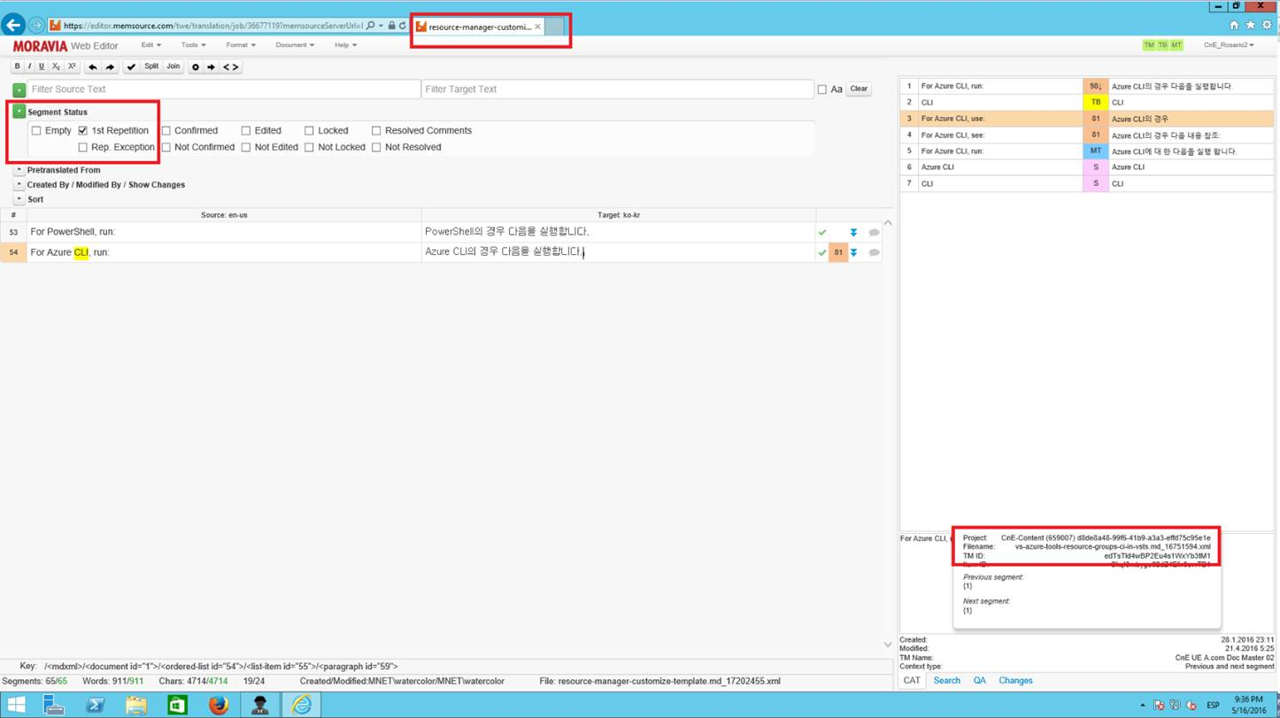

1. Once the files are handed back through Oddjob, the TM will be updated automatically.

# GitHub: Getting Started Guide

## Recording of the live training delivered by MS

<https://portal.moravia.com/prj/msce/LinguisticServices/partnerengagement/SitePages/Trainings%20for%20LMs.aspx?WikiPageMode=Edit&InitialTabId=Ribbon.EditingTools.CPEditTab&VisibilityContext=WSSWikiPage>

## Get familiar with Git Terms

If you're unfamiliar with Git, you might want to review some Git terminology: <https://help.github.com/articles/github-glossary>. In addition, this StackOverflow thread contains a glossary of Git terms you'll encounter in this set of steps: <http://stackoverflow.com/questions/7076164/terminology-used-by-git>

## Create a GitHub account and set up your profile

To contribute to the Azure technical content, you'll need a [GitHub](http://www.github.com/) account.

If you are a Microsoft contributor, you need to set up your GitHub account so you're clearly identified as a Microsoft employee. Set up your profile as follows:

* **Profile picture**: a picture of you (required)
* **Name**: your first and last name (required)
* **Email**: your Microsoft email address (required)
* **Company**: Microsoft Corporation (required)
* **Location**: list your location (required)

## Install Git for Windows

Install Git for Windows from <http://git-scm.com/download/win>. This download installs the Git version control system, and it installs Git Bash, the command-line app that you will use to interact with your local Git repository.

You can accept the default settings; if you want the commands to be available within the Windows command line, select the option that enables it.

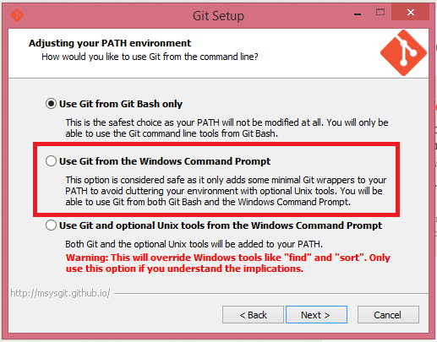

(Note: This is not the same as "Github for Windows". "Github for Windows" is a different GUI-based tool that will also work if you want to read up on yourself. <https://windows.github.com/>)

## Enable two-factor authentication

You have to enable two factor authentication (2FA) on your GitHub account if you are working in the private content repository. It's required in the private repository.

To enable this, follow the instructions in both the following GitHub help topics:

* [About Two-Factor Authentication](https://help.github.com/articles/about-two-factor-authentication/)
* [Creating an access token for command-line use](https://help.github.com/articles/creating-an-access-token-for-command-line-use/)

After you enable 2FA, you have to enter the access token instead of your GitHub password at the command prompt when you try to access a GitHub repository from the command line. The access token is not the authentication code that you get in a text message when you set up 2FA. It's a long string that looks something like this: fdd3b7d3d4f0d2bb2cd3d58dba54bd6bafcd8dee. A few notes about this:

* When you create your access token, save it in a text file to make it readily accessible when you need it.
* Later, when you need to paste the token, know there are two ways to paste in the command line:
  + Click the icon in the upper left corner of the command line window>Edit>Paste.
  + Right-click the icon in the upper left corner of the window and click Properties>Options>QuickEdit Mode. This configures the command line so you can paste by right-clicking in the command line window.

## What is GITHUB Pull Request (PR)?

GITHUB Pull Request (PR) is a methodology for submitting contribution to source code repository using GITHUB.

### What are you looking for in a Pull Request?

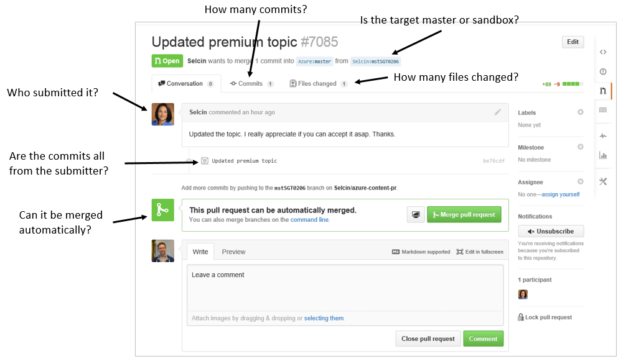

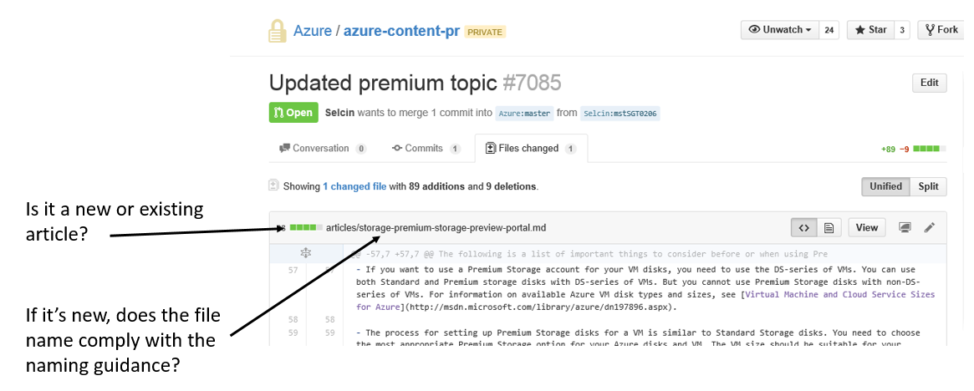

# Accessing Azure/acom string repository

The following sections are applicable only for Pull Request related to Azure.

## Associate your GitHub identity with your Microsoft identity

Go to the [Azure Open Source Portal](http://aka.ms/azuregithub). Through this portal you associate your GitHub account with your Microsoft domain account.

Click on the **Sign In** button to sign in with your GitHub account.

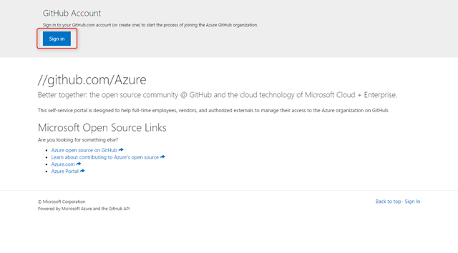

Authorize the Azure Open Source portal application by clicking on the **Authorize application** button.

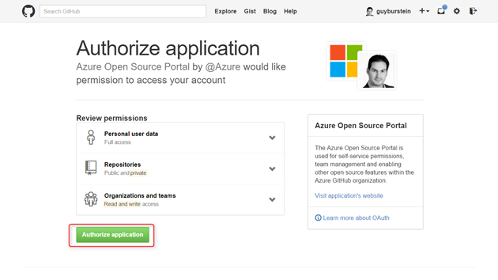

Your GitHub profile information will show at the top. To associate your Microsoft domain account with this GitHub profile, click on the **Sign In to Microsoft** button.

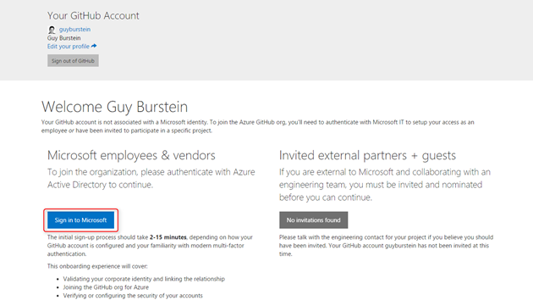

After you sign in, your Microsoft identity will show on the top right corner, and your GitHub identity will be associated with it.

Scroll down a little bit and agree to the Microsoft OSS Agreement by clicking the **I Agree** button.

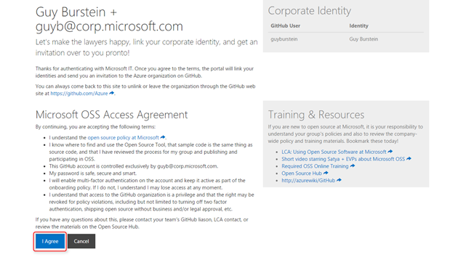

## Join the Azure organization on GitHub

GitHub just sent you an invitation to the Azure organization. Click on the **Open your Azure Invitation** button.

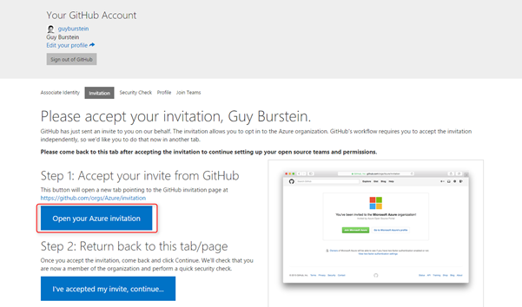

Accept the invitation by clicking on the **Join Microsoft Azure** button.

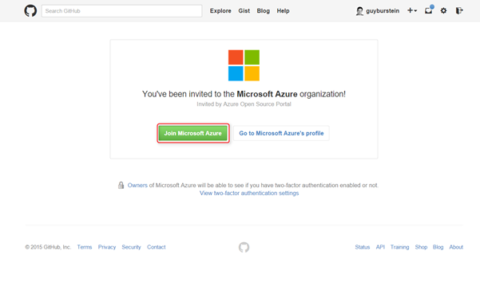

After you've accepted the invitation click on the **I've accepted my invite, continue...** button.

## Configure Multi Factor Authentication to protect your GitHub account

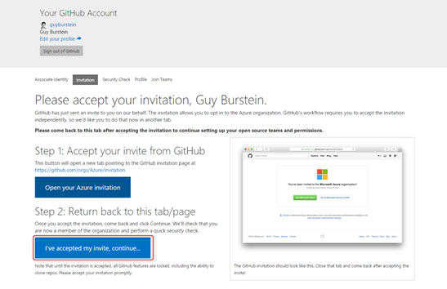

If you haven't already set up Multi Factor Authentication to protect your GitHub account, you'll be presented with this page. Click on the **Configure MFA** button to go to the GitHub page that guides you through configuring Multi Factor Authentication using an app or a text message.

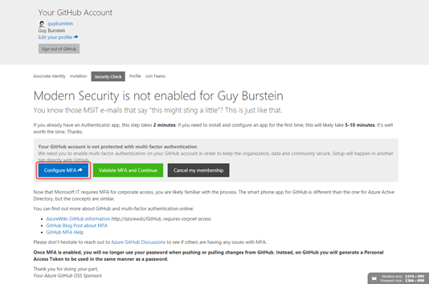

Once you're done configuring MFA, click the **Validate MFA and continue** button.

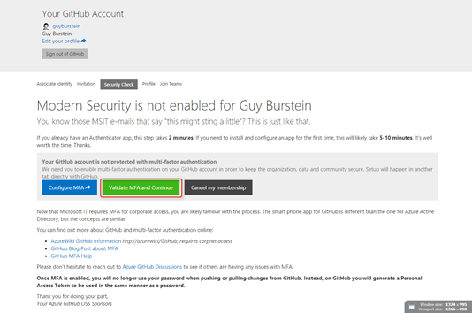

Choose whether you'd like to make your membership to the Azure organization public or not.

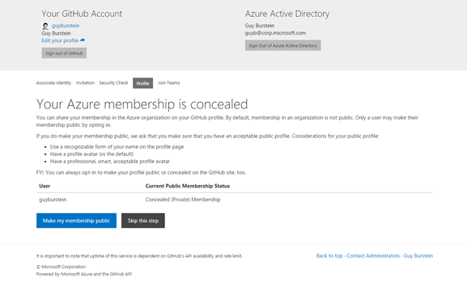

## Request access to the acom-read team

Once your identities are associated and you've enabled MFA, you can start join teams to get access to repos.

To contribute to ACOM, you need to request access to the **acom-read** team. Locate it on the list and click on the **Request to join** button next to it.

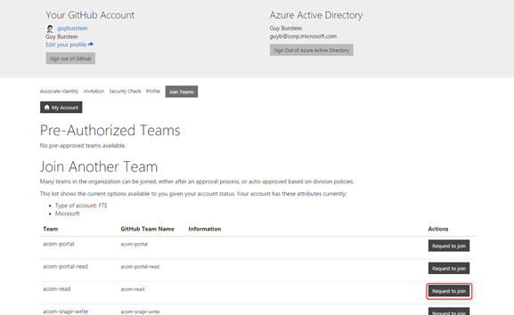

Fill in a business justification for the request and submit the request.

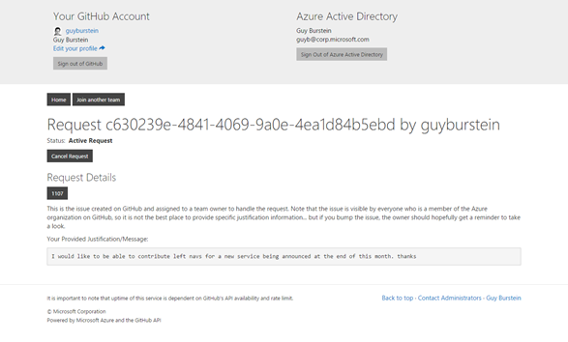

You can always go back to this page and see the status of this request. Once the request is approved, you should see it decision column.

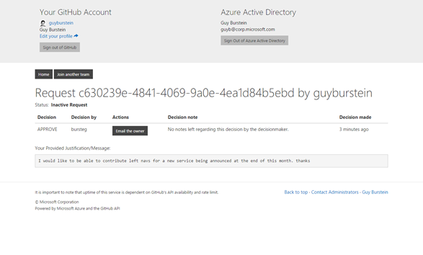

On the home screen of the Azure Open Source Portal, you can always see the teams you are a member of, and request access to additional teams.

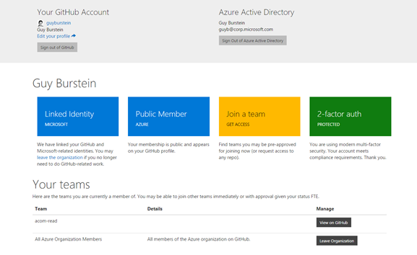

To confirm you have access to the ACOM repository, go to <https://github.com/Azure/acom>

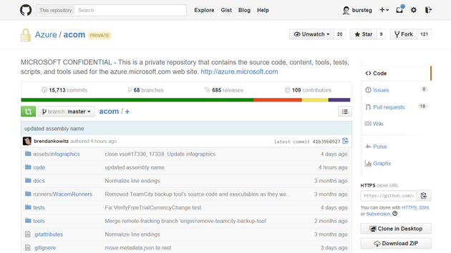

## How to ask permission to the Azure groups:

* 1. Go to: <https://azureopensource.azurewebsites.net/>
  2. Click on “Sign in”

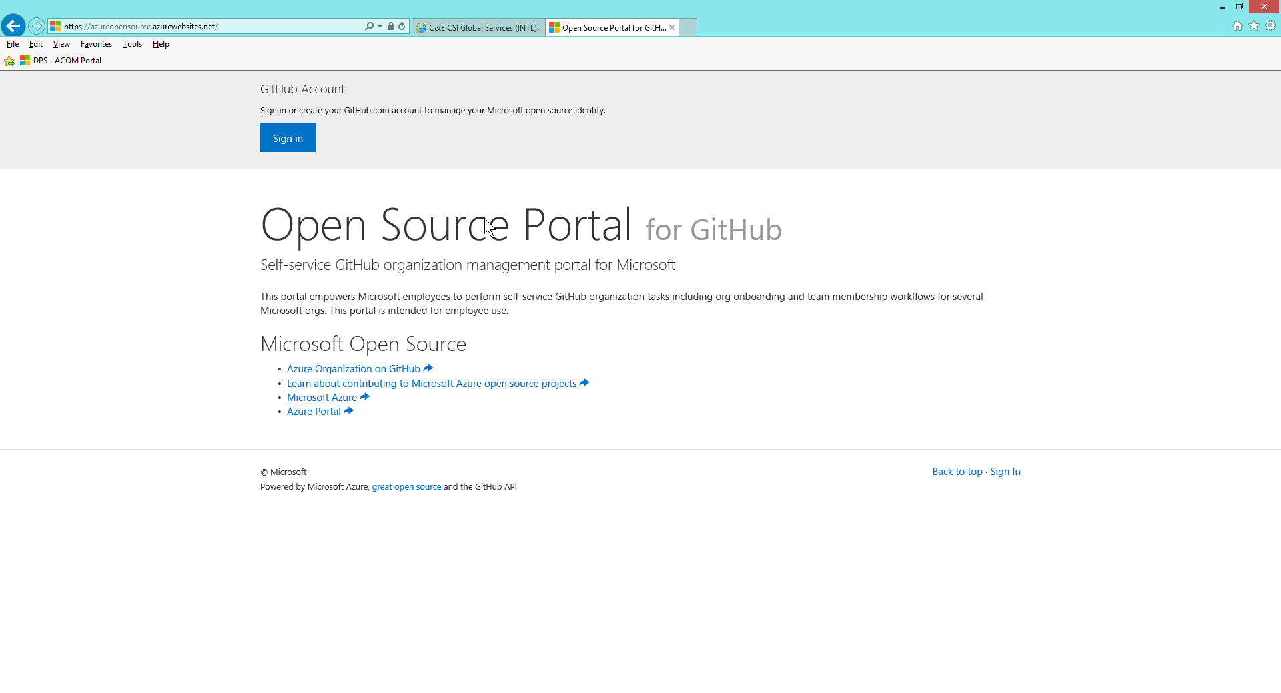

* 1. Enter your Github credentials

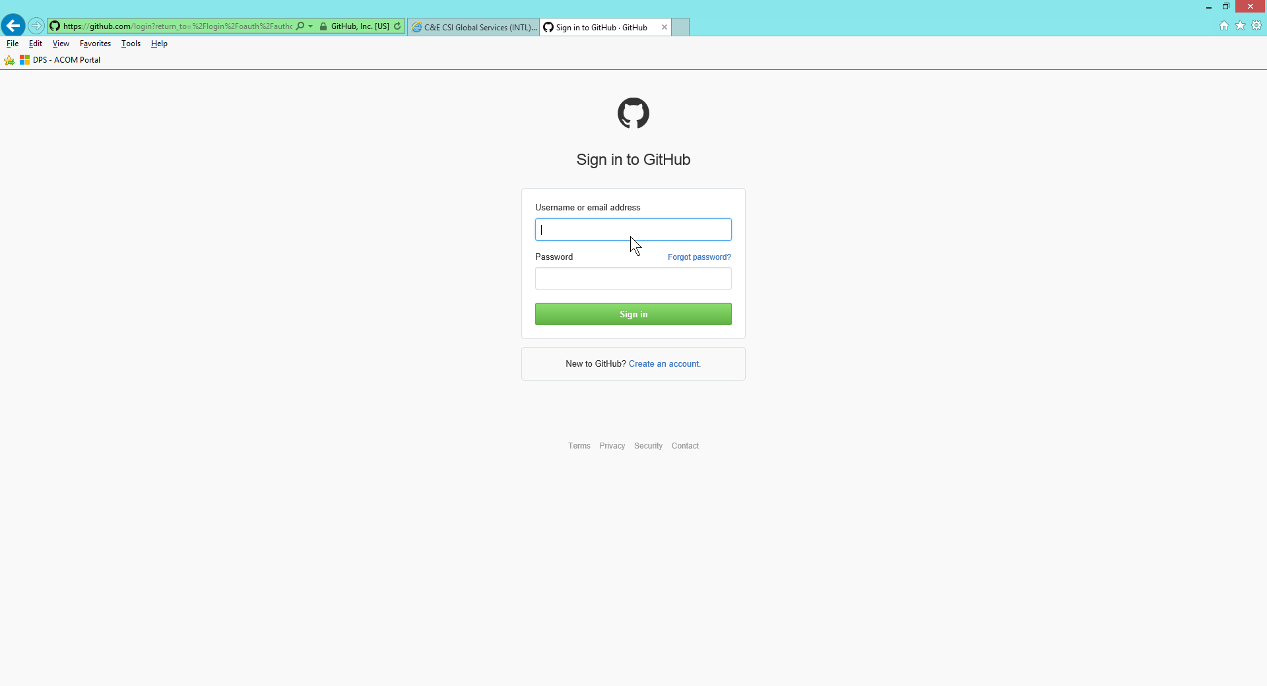

* 1. Click on 2-factor auth (green box)

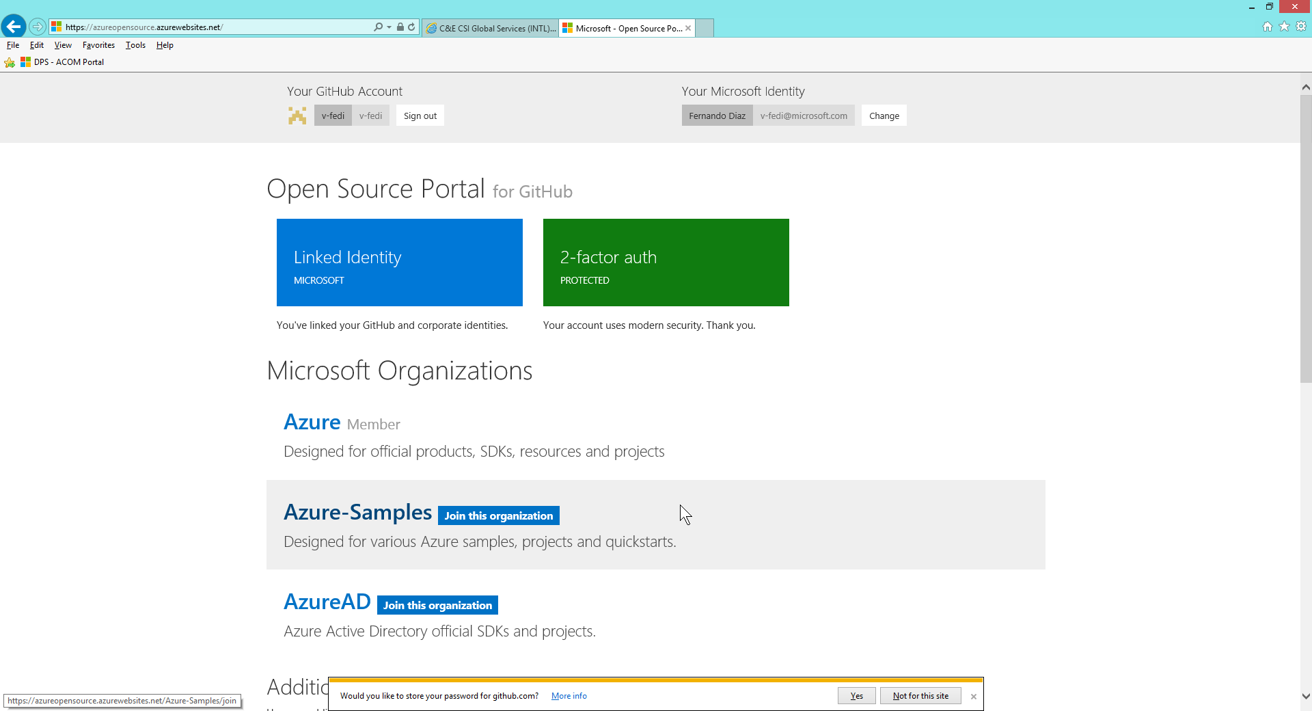

* 1. Click on “Go to the Azure portal”

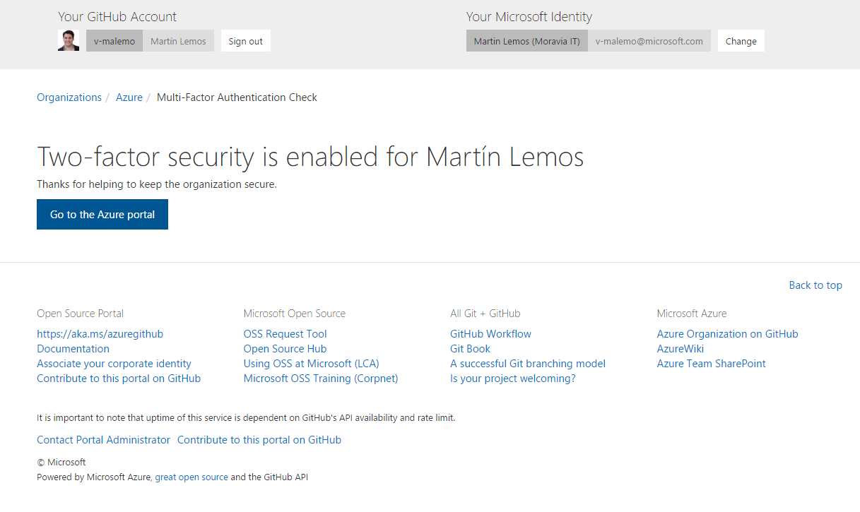

* 1. Click on “Join a team”

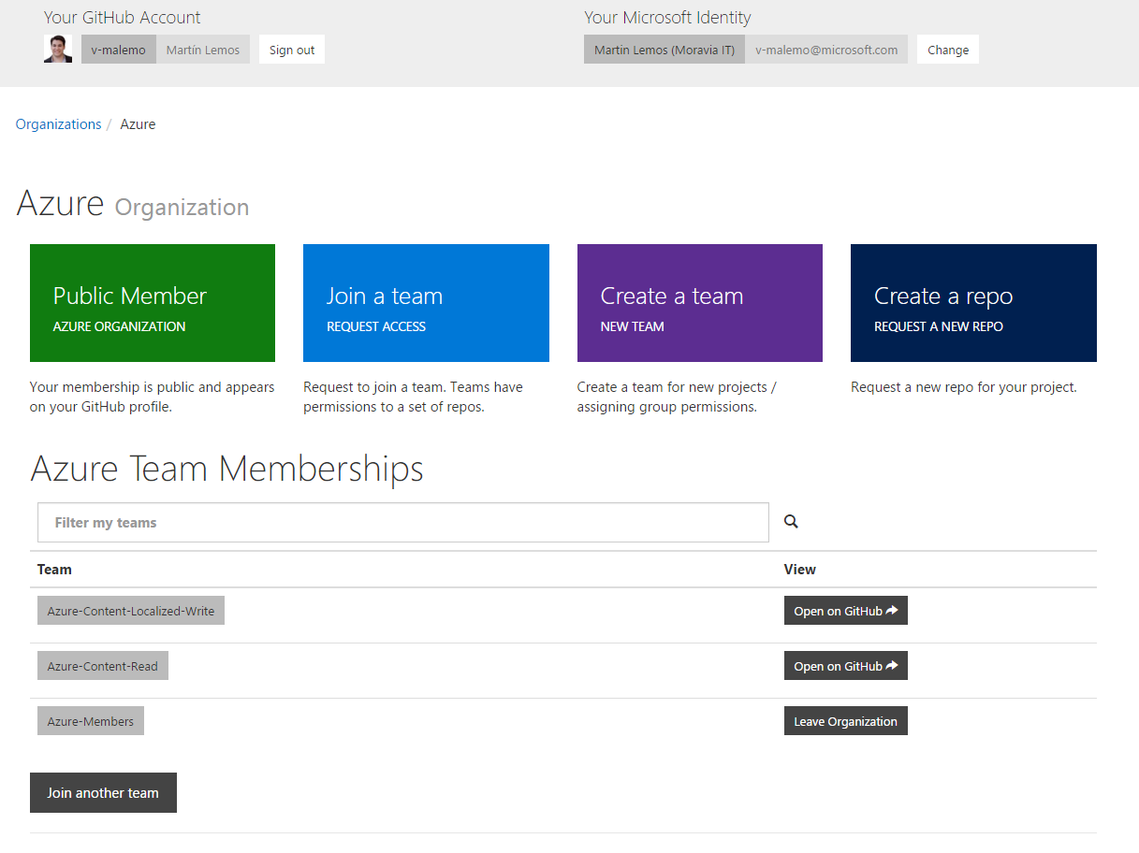

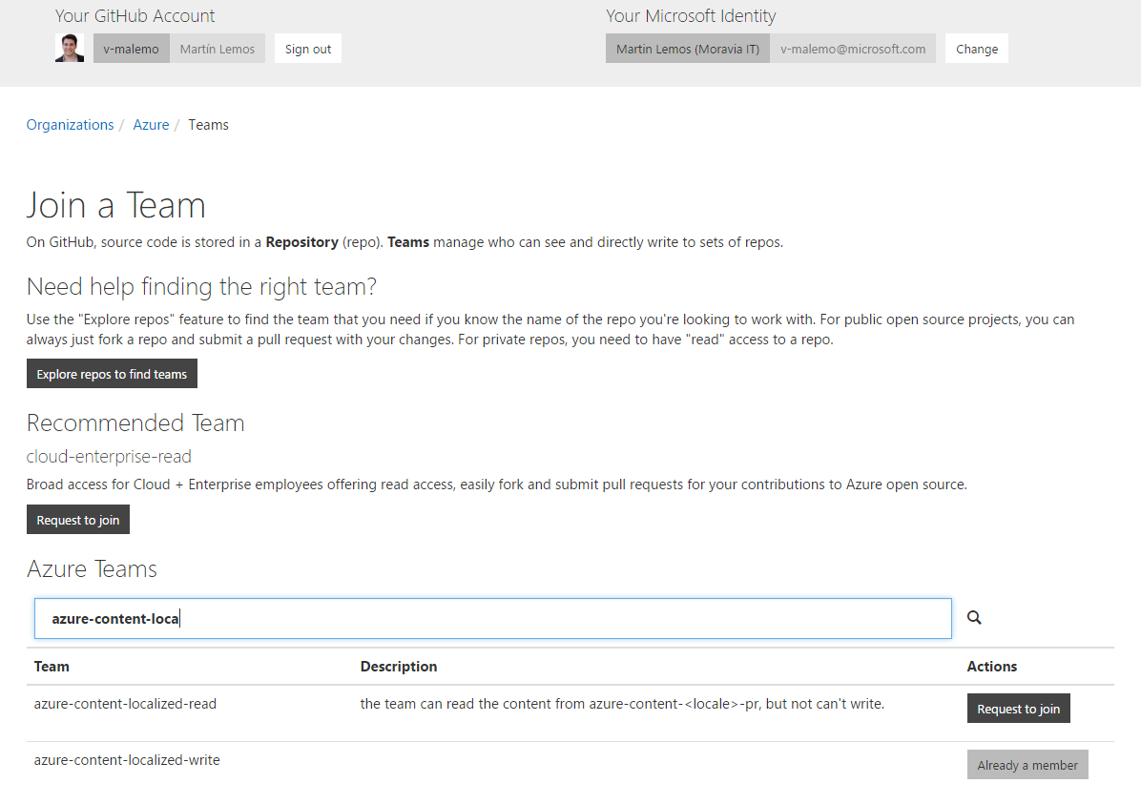

* 1. Search for the group azure-content-localized-writer
  2. Click on “Request to join”

You should have perms to these 3 groups:

**‘azure-content-localized-write’**

**‘azure-members’**

**‘azure-content-read’**